# Reading 4…20 mA signal with MCU

## Direct

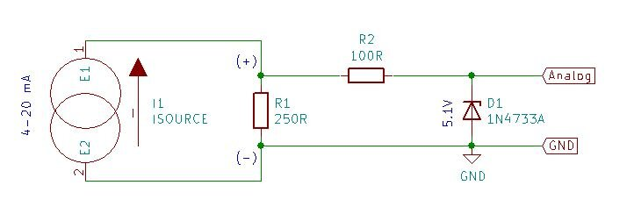

Instead of 250R resistor (which should work for 5V logic) estimate it as:

$$R_{sense=}\frac{V_{max}}{20mA}$$

And for 3.3V logic replace the Zenner for appropriate rating (not more than 3.6V)

## Operational amplifier

To not load the interface circuit, it’s recommended to implement an electronic buffer based on an operation amplifier. An electronic circuit that is commonly used for 4-20 mA interface to digital devices with analog inputs is shown

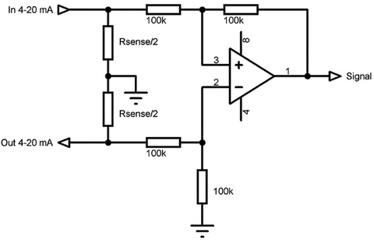

Where

$$R_{sense=}\frac{V_{max}}{20mA}$$

## Separate ADC IC

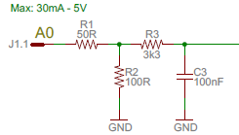

Here, the output can be connected to ADS1115

## MCU with isolation

Consider having the isolating optocoupler alike HCNR201 / HCNR200 / LOC110

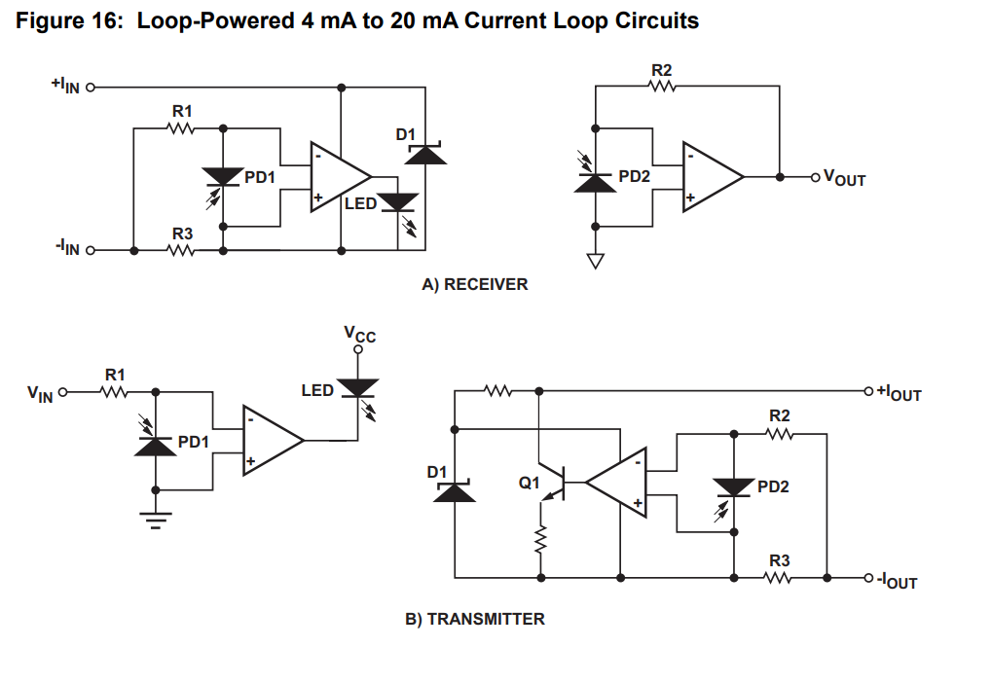

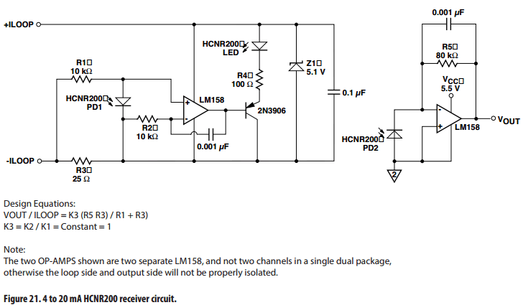

NOTE:! Those OPAMPs are the separate IC, otherwise there is no isolation!

## Specialized IC

RCV420 : 4…20 mA to 0.. 5V, however can be also narrowed down to 0 … 3.3V according to section “Gain and Offset Adjustments”:

$$\frac{V_{out}}{I_{in}}=0.3125\frac{R_{X}}{R_{X}+R_{S}}$$

$R_{S}$ is resistance of the internal current shunt of RCV420 and is equal to 75 Ω